1. Download the file, audio, video and image with the help of php download code.

* **File**

Input:

<?php

$file_url="https://riptutorial.com/Download/php.pdf";

header("Content-Type: application/octet-stream");

header("Content-Transfer-Encoding: utf-8");

header("Content-disposition: attachment;filename=\"".basename($file_url)."\"");

readfile($file_url);

?>

Output:



* **Audio**

Input:

$file_url="mrpglu.audio.mp3";

header("Content-Type: application/octet-stream");

header("Content-Transfer-Encoding: utf-8");

header("Content-disposition: attachment;filename=\"".basename($file_url)."\"");

readfile($file_url);

Output:

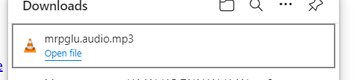

* **Image**

Input:

$file_url="mrpglu.audio.pglu.jpeg";

header("Content-Type: application/octet-stream");

header("Content-Transfer-Encoding: utf-8");

header("Content-disposition: attachment;filename=\"".basename($file_url)."\"");

readfile($file_url);

Output:



* **Video**

Input:

$file_url="mrpglu.audio.pglu-video.mov";

header("Content-Type: application/octet-stream");

header("Content-Transfer-Encoding: utf-8");

header("Content-disposition: attachment;filename=\"".basename($file_url)."\"");

readfile($file_url);

Output:

